| **dlsu_logo.gif** | **Picture 1** |
| --- | --- |

**DE LA SALLE UNIVERSITY**

**COLLEGE OF ENGINEERING**

**SY 2023-2024, TERM 2**

**SOFTWARE DESIGN LABORATORY**

**(LBYCPD2)**

**LABORATORY # 4**

**Software Requirements Specifications - SRS**

**NAME:**  **GOCHUICO, DAVID ZACHARY**

**ONG, AIDAN MATTHEW**

**DIMAPILIS, DAVID BRIAN**

**STUDENT ID NUMBER: 12204137**

**12215228**

**12212504**

**STUDENT EMAIL ADD: david\_gochuico@dlsu.edu.ph**

**aidan\_ong@dlsu.edu.ph**

**david\_dimapilis@dlsu.edu.ph**

**STUDENT CONTACT NO: 09228182857**

**09391812517**

**09159734477**

**COURSE CODE: LBYCPD2**

**SECTION:** **EQ1**

**SCHEDULE: SATURDAY (7:30-10:30)**

**INSTRUCTOR: Engr. Bernard G. Yasay**

**STUDENT SIGNATURE: 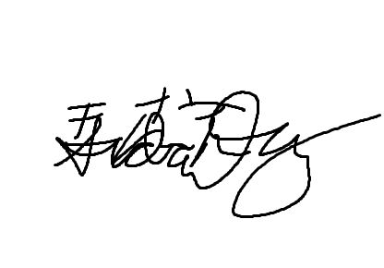**

**DATE SUBMITTED: \_\_, February 2024**

1. **EXERCISES**

# Introduction

# Purpose

*This document aims to provide an in-depth overview of the proposed Point of Sale (POS) system and Business Accounting system for the clients at XCE. It will cover the system's objectives, functionalities, interfaces, operations, limitations, and responses to external factors. It is designed for the use of the developers and the client involved in the system's development and implementation.*

# Scope

1. Software Product(s):

The software product to be produced is a fully functional Point of Sales System (POS) with an integrated accounting module.

1. **The POS system will facilitate sales transactions, inventory management, customer interactions, receipt printing, and will integrate an automated accounting system that will handle financial transactions, generate financial reports for a given time period and ensure accurate record-keeping.**
2. **Application and benefits:  
   The application of this software helps the business XCE with an efficient and streamlined approach to manage sales, operations and financial data. The system aims to benefit the \_\_\_/asdf**

*In this subsection:*

* + 1. *Identify the software product(s) to be produced by name*
    2. *Explain what the software product(s) will, and, if necessary, will not do*
    3. *Describe the application of the software being specified, including relevant benefits, objectives, and goals*
    4. *Be consistent with similar statements in higher-level specifications if they exist*

*This should be an executive-level summary. Do not enumerate the whole requirements list here.*

# Definitions, Acronyms, and Abbreviations

| *TERM* | *DEFINITION* |
| --- | --- |
| *Point of Sale (POS)* | *A retail system comprising of both hardware and software that completes transactions, including payment processing.* |
| *XCE* | *Client Startup Business name* |
|  |  |
|  |  |